UML - Use Case Diagrams

Use case diagrams are used to gather the requirements of a system including internal and external influences. These requirements are mostly design requirements. Hence, when a system is analyzed to gather its functionalities, use cases are prepared and actors are identified.
When the initial task is complete, use case diagrams are modelled to present the outside view.
In brief, the purposes of use case diagrams can be said to be as follows −
- Used to gather the requirements of a system.
- Used to get an outside view of a system.
- Identify the external and internal factors influencing the system.
- Show the interaction among the requirements are actors.

How to Draw a Use Case Diagram?
Use case diagrams are considered for high level requirement analysis of a system. When the requirements of a system are analyzed, the functionalities are captured in use cases.
We can say that use cases are nothing but the system functionalities written in an organized manner. The second thing which is relevant to use cases are the actors. Actors can be defined as something that interacts with the system.
Actors can be a human user, some internal applications, or may be some external applications. When we are planning to draw a use case diagram, we should have the following items identified.
- Functionalities to be represented as use case
- Actors
- Relationships among the use cases and actors.
Use case diagrams are drawn to capture the functional requirements of a system. After identifying the above items, we have to use the following guidelines to draw an efficient use case diagram
- The name of a use case is very important. The name should be chosen in such a way so that it can identify the functionalities performed.
- Give a suitable name for actors.
- Show relationships and dependencies clearly in the diagram.
- Do not try to include all types of relationships, as the main purpose of the diagram is to identify the requirements.
- Use notes whenever required to clarify some important points.
Following is a sample use case diagram representing the order management system. Hence, if we look into the diagram then we will find three use cases (Order, SpecialOrder, and NormalOrder) and one actor which is the customer.
The SpecialOrder and NormalOrder use cases are extended from Order use case. Hence, they have extended relationship. Another important point is to identify the system boundary, which is shown in the picture. The actor Customer lies outside the system as it is an external user of the system.
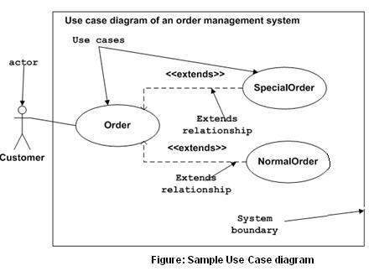

Where to Use a Use Case Diagram?
As we have already discussed there are five diagrams in UML to model the dynamic view of a system. Now each and every model has some specific purpose to use. Actually these specific purposes are different angles of a running system.
To understand the dynamics of a system, we need to use different types of diagrams. Use case diagram is one of them and its specific purpose is to gather system requirements and actors.
Use case diagrams specify the events of a system and their flows. But use case diagram never describes how they are implemented. Use case diagram can be imagined as a black box where only the input, output, and the function of the black box is known.
These diagrams are used at a very high level of design. This high level design is refined again and again to get a complete and practical picture of the system. A well-structured use case also describes the pre-condition, post condition, and exceptions. These extra elements are used to make test cases when performing the testing.
Although use case is not a good candidate for forward and reverse engineering, still they are used in a slightly different way to make forward and reverse engineering. The same is true for reverse engineering. Use case diagram is used differently to make it suitable for reverse engineering.
In forward engineering, use case diagrams are used to make test cases and in reverse engineering use cases are used to prepare the requirement details from the existing application.

What is a use case diagram?
In the Unified Modeling Language (UML), a use case diagram can summarize the details of your system's users (also known as actors) and their interactions with the system. To build one, you'll use a set of specialized symbols and connectors. An effective use case diagram can help your team discuss and represent:
- Scenarios in which your system or application interacts with people, organizations, or external systems
- Goals that your system or application helps those entities (known as actors) achieve
- The scope of your system

When to apply use case diagrams
A use case diagram doesn't go into a lot of detail—for example, don't expect it to model the order in which steps are performed. Instead, a proper use case diagram depicts a high-level overview of the relationship between use cases, actors, and systems. Experts recommend that use case diagrams be used to supplement a more descriptive textual use case.
UML is the modeling toolkit that you can use to build your diagrams. Use cases are represented with a labeled oval shape. Stick figures represent actors in the process, and the actor's participation in the system is modeled with a line between the actor and use case. To depict the system boundary, draw a box around the use case itself.
UML use case diagrams are ideal for:
- Representing the goals of system-user interactions
- Defining and organizing functional requirements in a system
- Specifying the context and requirements of a system
- Modeling the basic flow of events in a use case
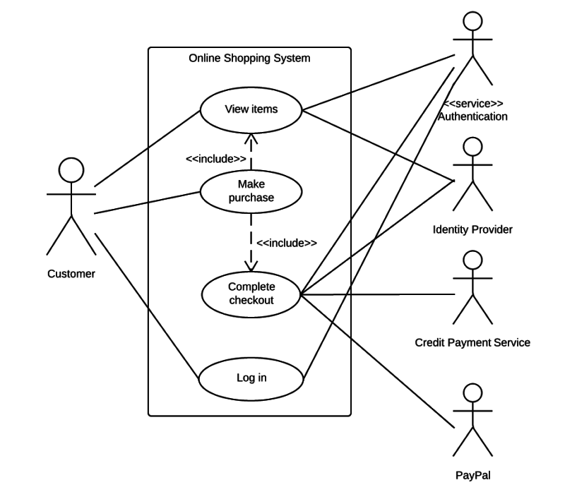
Diagramming is quick and easy with Lucidchart. Start a free trial today to start creating and collaborating.

Use case diagram components
To answer the question, "What is a use case diagram?" you need to first understand its building blocks. Common components include:
- Actors: The users that interact with a system. An actor can be a person, an organization, or an outside system that interacts with your application or system. They must be external objects that produce or consume data.
- System: A specific sequence of actions and interactions between actors and the system. A system may also be referred to as a scenario.
- Goals: The end result of most use cases. A successful diagram should describe the activities and variants used to reach the goal.
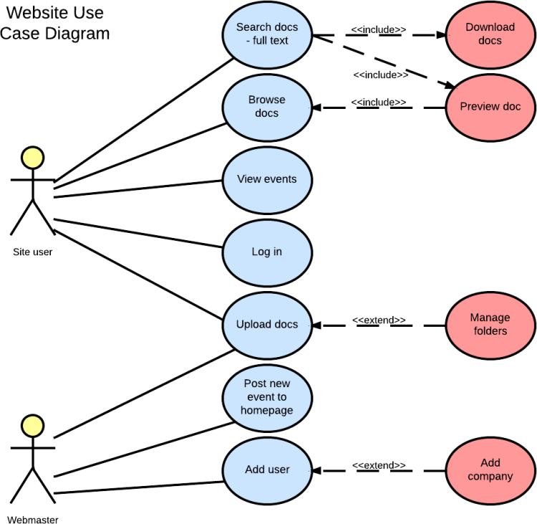

Use case diagram symbols and notation
The notation for a use case diagram is pretty straightforward and doesn't involve as many types of symbols as other UML diagrams. You can use this guide to learn how to draw a use case diagram if you need a refresher. Here are all the shapes you will be able to find in Lucidchart:
- Use cases: Horizontally shaped ovals that represent the different uses that a user might have.
- Actors: Stick figures that represent the people actually employing the use cases.
- Associations: A line between actors and use cases. In complex diagrams, it is important to know which actors are associated with which use cases.
- System boundary boxes: A box that sets a system scope to use cases. All use cases outside the box would be considered outside the scope of that system. For example, Psycho Killer is outside the scope of occupations in the chainsaw example found below.
- Packages: A UML shape that allows you to put different elements into groups. Just as with component diagrams, these groupings are represented as file folders.

Use case diagram examples

Book publishing use case diagram example
This use case diagram is a visual representation of the process required to write and publish a book. Whether you’re an author, an agent, or a bookseller, inserting this diagram into your use case scenario can help your team publish the next big hit. Try this demo template to get started on your own.
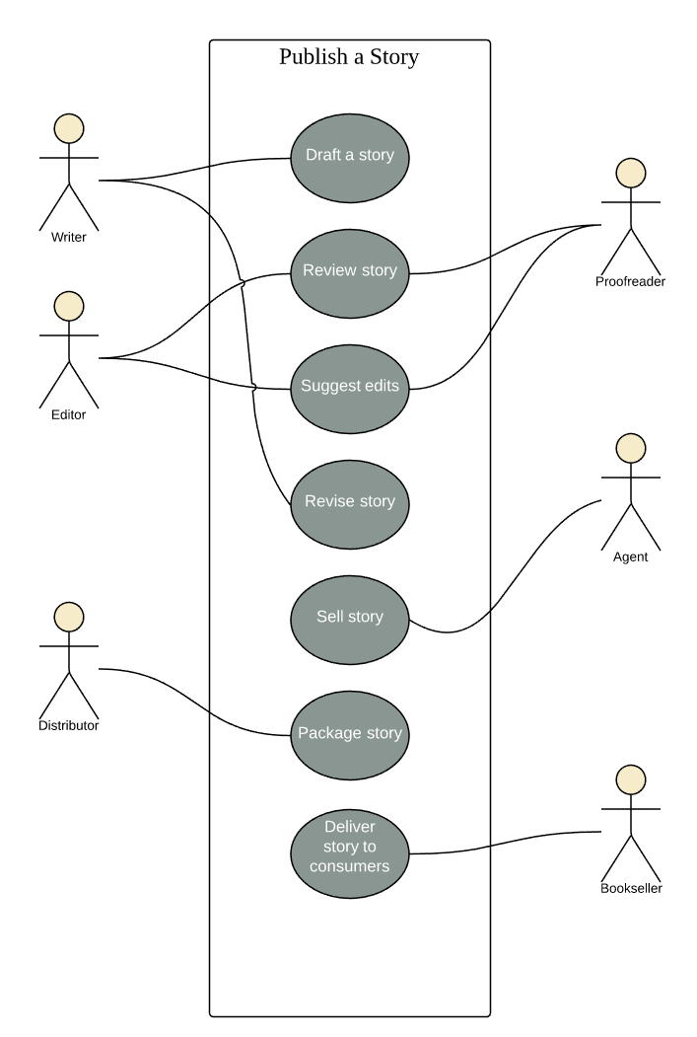

Railway reservation use case diagram example
You can adapt this template for any process where a customer purchases a service. With attractive color schemes, text that’s easy to read and edit, and a wide-ranging UML shape library, you’re ready to go! Click to try out this template on your own.
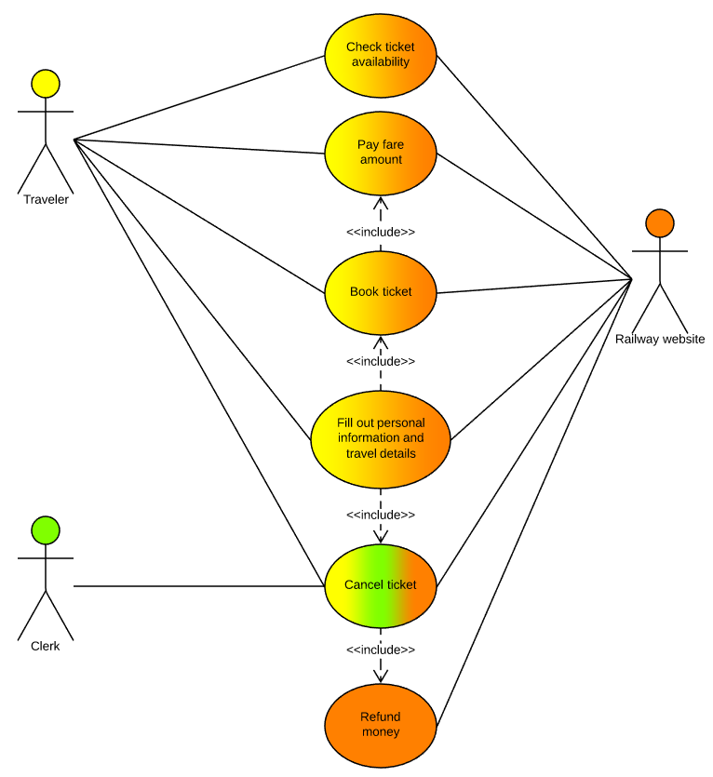

Chainsaw use case diagram example
Consider this example: A man with a chainsaw interacts with the environment around him. Depending on the situation and the context of the situation, he might fall into one of many different use cases. Does he seem to be on his way to work? Is there anything ominous about the way he is wielding his chainsaw? For example, if he is using the chainsaw in a non-occupational setting, we might have reason to think that he falls within the scope of "scary."
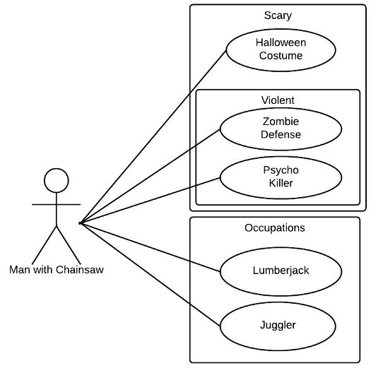

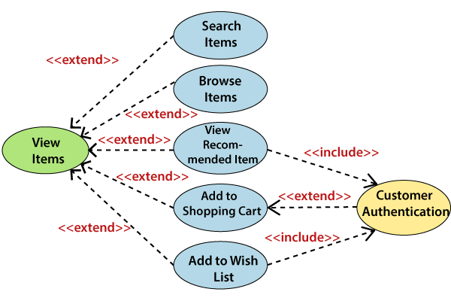

Use Case Diagram Relationships Explained with Examples
Updated on: 16 July 2021
When it comes to drawing use case diagrams one area many struggles with is showing various relationships in use case diagrams. In fact many tend to confuse <<extend>>, <<include>> and generalization. This article will look into various use case diagram relationships in detail and explain them using examples. To get a deeper understanding of use cases, check out our use case diagram tutorial. If you want to draw them while learning you can use our tool to create use case diagrams.
There can be 5 relationship types in a use case diagram.
- Association between actor and use case
- Generalization of an actor
- Extend between two use cases
- Include between two use cases
- Generalization of a use case
Let’s take a look at these relationships in detail.

Association Between Actor and Use Case
This one is straightforward and present in every use case diagram. Few things to note.
- An actor must be associated with at least one use case.
- An actor can be associated with multiple use cases.
- Multiple actors can be associated with a single use case.
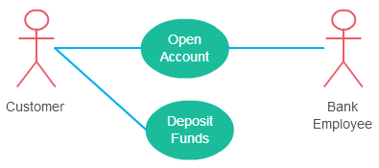
Different ways association relationship appears in use case diagrams
Check out the use case diagram guidelines for other things to consider when adding an actor.

Generalization of an Actor
Generalization of an actor means that one actor can inherit the role of the other actor. The descendant inherits all the use cases of the ancestor. The descendant has one or more use cases that are specific to that role. Let’s expand the previous use case diagram to show the generalization of an actor.
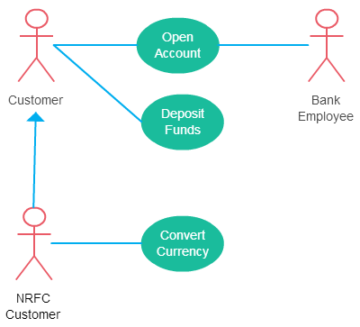
A generalized actor in an use case diagram

Extend Relationship Between Two Use Cases
Many people confuse the extend relationship in use cases. As the name implies it extends the base use case and adds more functionality to the system. Here are a few things to consider when using the <<extend>> relationship.
- The extending use case is dependent on the extended (base) use case. In the below diagram the “Calculate Bonus” use case doesn’t make much sense without the “Deposit Funds” use case.
- The extending use case is usually optional and can be triggered conditionally. In the diagram, you can see that the extending use case is triggered only for deposits over 10,000 or when the age is over 55.
- The extended (base) use case must be meaningful on its own. This means it should be independent and must not rely on the behavior of the extending use case.
Lets expand our current example to show the <<extend>> relationship.
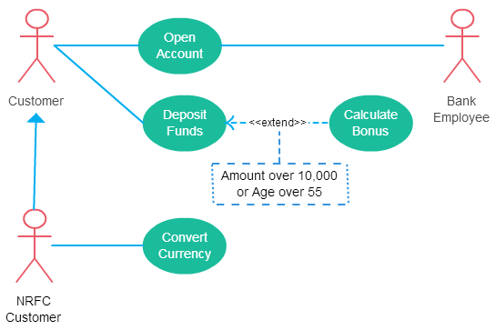
Extend relationship in use case diagrams
Although extending use case is optional most of the time it is not a must. An extending use case can have non-optional behavior as well. This mostly happens when your modeling complex behaviors.
For example, in an accounting system, one use case might be “Add Account Ledger Entry”. This might have extending use cases “Add Tax Ledger Entry” and “Add Payment Ledger Entry”. These are not optional but depend on the account ledger entry. Also, they have their own specific behavior to be modeled as a separate use case.

Include Relationship Between Two Use Cases
Include relationship show that the behavior of the included use case is part of the including (base) use case. The main reason for this is to reuse common actions across multiple use cases. In some situations, this is done to simplify complex behaviors. Few things to consider when using the <<include>> relationship.
- The base use case is incomplete without the included use case.
- The included use case is mandatory and not optional.
Lest expand our banking system use case diagram to show include relationships as well.
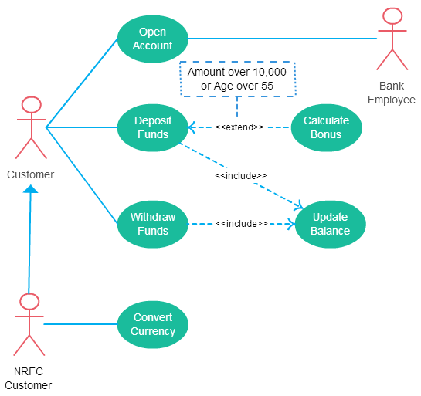
Includes is usually used to model common behavior
For some further reading regarding the difference between extend and include relationships in use case diagrams check this StackOverflow link.

Generalization of a Use Case
This is similar to the generalization of an actor. The behavior of the ancestor is inherited by the descendant. This is used when there is common behavior between two use cases and also specialized behavior specific to each use case.
For example, in the previous banking example, there might be a use case called “Pay Bills”. This can be generalized to “Pay by Credit Card”, “Pay by Bank Balance” etc.

UML - Class Diagram
Class diagram is a static diagram. It represents the static view of an application. Class diagram is not only used for visualizing, describing, and documenting different aspects of a system but also for constructing executable code of the software application.
Class diagram describes the attributes and operations of a class and also the constraints imposed on the system. The class diagrams are widely used in the modeling of objectoriented systems because they are the only UML diagrams, which can be mapped directly with object-oriented languages.
Class diagram shows a collection of classes, interfaces, associations, collaborations, and constraints. It is also known as a structural diagram.

Purpose of Class Diagrams
The purpose of class diagram is to model the static view of an application. Class diagrams are the only diagrams which can be directly mapped with object-oriented languages and thus widely used at the time of construction.
UML diagrams like activity diagram, sequence diagram can only give the sequence flow of the application, however class diagram is a bit different. It is the most popular UML diagram in the coder community.
The purpose of the class diagram can be summarized as −
- Analysis and design of the static view of an application.
- Describe responsibilities of a system.
- Base for component and deployment diagrams.
- Forward and reverse engineering.

How to Draw a Class Diagram?
Class diagrams are the most popular UML diagrams used for construction of software applications. It is very important to learn the drawing procedure of class diagram.
Class diagrams have a lot of properties to consider while drawing but here the diagram will be considered from a top level view.
Class diagram is basically a graphical representation of the static view of the system and represents different aspects of the application. A collection of class diagrams represent the whole system.
The following points should be remembered while drawing a class diagram −
- The name of the class diagram should be meaningful to describe the aspect of the system.
- Each element and their relationships should be identified in advance.
- Responsibility (attributes and methods) of each class should be clearly identified
- For each class, minimum number of properties should be specified, as unnecessary properties will make the diagram complicated.
- Use notes whenever required to describe some aspect of the diagram. At the end of the drawing it should be understandable to the developer/coder.
- Finally, before making the final version, the diagram should be drawn on plain paper and reworked as many times as possible to make it correct.
The following diagram is an example of an Order System of an application. It describes a particular aspect of the entire application.
- First of all, Order and Customer are identified as the two elements of the system. They have a one-to-many relationship because a customer can have multiple orders.
- Order class is an abstract class and it has two concrete classes (inheritance relationship) SpecialOrder and NormalOrder.
- The two inherited classes have all the properties as the Order class. In addition, they have additional functions like dispatch () and receive ().
The following class diagram has been drawn considering all the points mentioned above.
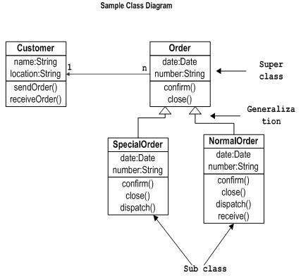

Where to Use Class Diagrams?
Class diagram is a static diagram and it is used to model the static view of a system. The static view describes the vocabulary of the system.
Class diagram is also considered as the foundation for component and deployment diagrams. Class diagrams are not only used to visualize the static view of the system but they are also used to construct the executable code for forward and reverse engineering of any system.
Generally, UML diagrams are not directly mapped with any object-oriented programming languages but the class diagram is an exception.
Class diagram clearly shows the mapping with object-oriented languages such as Java, C++, etc. From practical experience, class diagram is generally used for construction purpose.
In a nutshell it can be said, class diagrams are used for −
- Describing the static view of the system.
- Showing the collaboration among the elements of the static view.
- Describing the functionalities performed by the system.
- Construction of software applications using object oriented languages.

